The Design Idea Behind GraphicsMagic Selection

by Ma Xiaoguang and Ma Xiaoming

Aug. 25, 2012

What is a selection?

A selection, as in our mind and also in GraphicsMagic, is actually a mask. We could create any shaped selection, such as rectangular or elliptical selections, even arbitrary shaped selection created by a polygon or even by a Magic Wand. Any of subsequently created selection could be combined into the previous one to make a whole single selection.

With this mask, we could mimic a selection like a one in Photoshop or GIMP. Just get the bounding box of a selection, crop the corresponding area from a background image as the foreground of the selection. Make any changes to the foreground image, like drawing brush stroke on it, and rendering it against the background image with selection mask. By changing the alpha channel of each pixels on the foreground with corresponding mask values, we could make sure that only the pixels that fall inside the selected area will be rendered, others will be untouched.

For example, we created an elliptical selection:

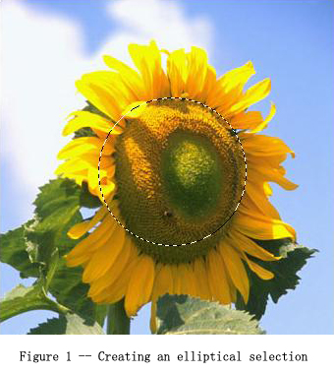

In GraphicsMagic, we first create a mask, like this:
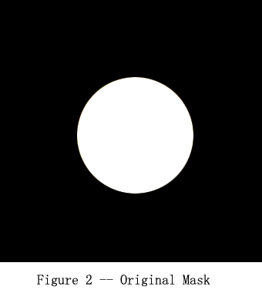
With the original mask in Figure 2, we could find out a bounding box that surrounds the white area (the selected area). If such a bounding box is found, then we could crop a small mask from the original mask, like the one in Figure 3:

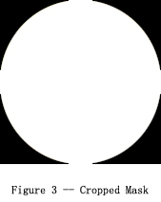
And we also crop the same area from the background image as a foreground bitmap for the selection, like Figure 4:

